**PART 2**

**Smart Agriculture System Proposal**

**Objective**

Design an AI-driven IoT system to enhance crop yield predictions and optimize farming practices through real-time environmental monitoring and data-driven insights.

**System Overview**

The system integrates IoT sensors, edge AI, and cloud analytics to monitor soil and environmental conditions, predict crop yields, and provide actionable recommendations. It targets small to medium farms, enabling precision agriculture with minimal infrastructure costs.

**Sensors Required**

* **Soil Moisture Sensor**: Measures water content to optimize irrigation (e.g., capacitive sensors).
* **Temperature/Humidity Sensor**: Tracks ambient conditions (e.g., DHT22).
* **Light Sensor**: Monitors sunlight exposure for photosynthesis optimization (e.g., BH1750).
* **Soil Nutrient Sensor**: Assesses NPK levels for fertilization planning.
* **Weather Station**: Collects rainfall and wind data for holistic environmental insights.

**AI Model**

A **Random Forest Regressor** is proposed for crop yield prediction due to its robustness with tabular sensor data and interpretability. Inputs include:

* Soil moisture, temperature, humidity, light intensity, NPK levels, rainfall.
* Historical yield data and crop type (e.g., maize, wheat).  
  The model is trained on regional agricultural datasets, fine-tuned on farm-specific data, and deployed on edge devices (e.g., Raspberry Pi) for real-time predictions. Cloud-based retraining ensures model updates with new data.

**Data Flow**

1. **Sensor Data Collection**: Sensors transmit data via LoRaWAN to an edge gateway.
2. **Edge Processing**: A TensorFlow Lite model predicts yields and flags anomalies (e.g., low moisture).
3. **Cloud Integration**: Aggregated data is sent to a cloud server (e.g., AWS IoT) for storage and retraining.
4. **Farmer Interface**: Mobile app displays predictions and recommendations (e.g., irrigate now, adjust fertilizer).

**Benefits**

* **Real-Time Insights**: Edge AI enables instant yield predictions and alerts, reducing crop loss.
* **Cost Efficiency**: Low-power sensors and edge processing minimize cloud costs.
* **Scalability**: LoRaWAN supports wide-area coverage, suitable for large farms.
* **Sustainability**: Optimizes water and fertilizer use, reducing environmental impact.

**Implementation Plan**

* **Phase 1**: Deploy sensors and edge gateway on a pilot farm.
* **Phase 2**: Train and deploy the AI model, integrating with a mobile app.
* **Phase 3**: Scale to multiple farms, leveraging cloud analytics for regional insights.

**Conclusion**

This system empowers farmers with data-driven tools to maximize yields while promoting sustainable practices. The combination of IoT and AI ensures real-time, scalable, and cost-effective agriculture solutions.

**DIAGRAM** 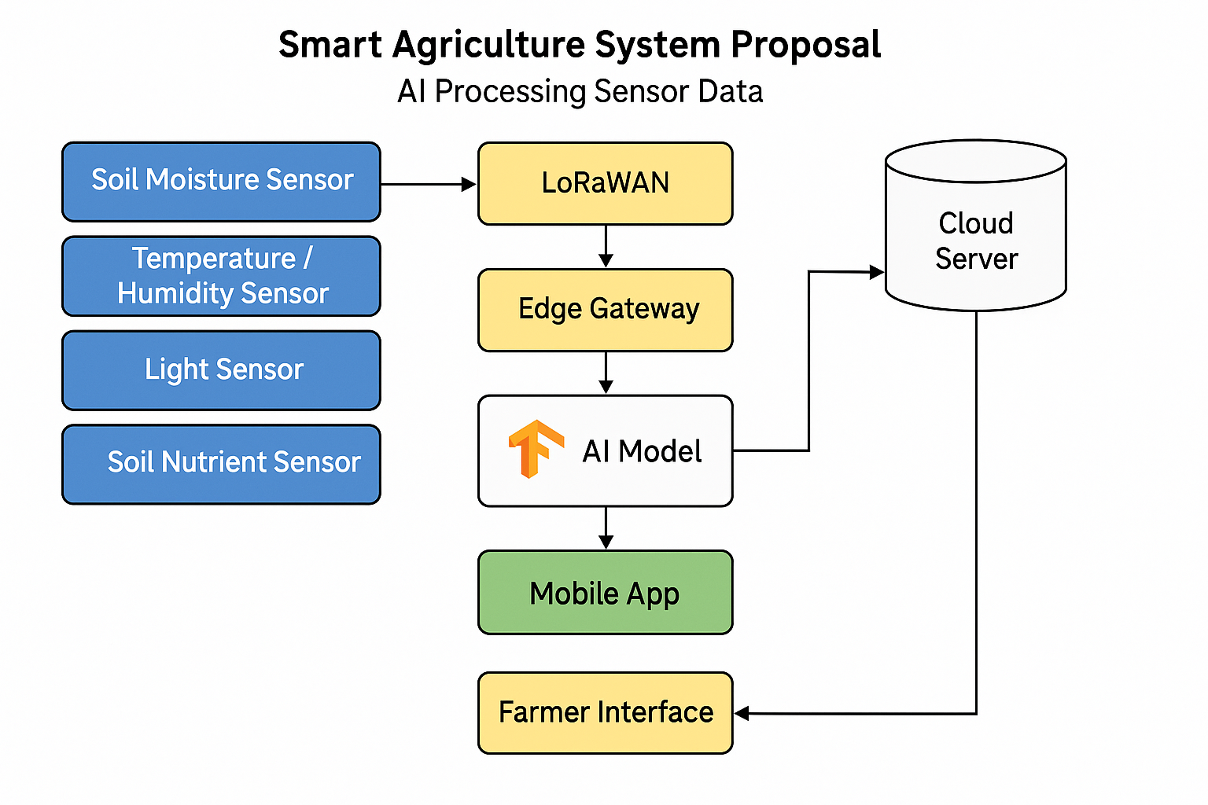

**TASK 3**

**Ethics in Personalized Medicine: TCGA Analysis**

The Cancer Genomic Atlas (TCGA) dataset, with genomic profiles from over 11,000 patients across 33 cancer types, is a cornerstone for AI-driven personalized medicine. However, its use in recommending treatments raises ethical concerns, primarily due to potential biases. A key issue is the underrepresentation of ethnic groups. TCGA data predominantly includes patients of European descent (over 70%), with limited representation of African, Asian, or Indigenous populations. This skew can lead AI models to generate treatment recommendations that are less effective or inapplicable for underrepresented groups, exacerbating health disparities. For example, genetic variants like BRCA1 mutations vary across ethnicities, and a model trained on biased data may miss critical patterns, leading to misdiagnoses or suboptimal therapies.

Socioeconomic factors further compound biases. TCGA data often comes from well-funded research hospitals, underrepresenting patients from low-income or rural communities who lack access to such facilities. This can bias AI toward treatments suited for patients with better healthcare access, marginalizing vulnerable populations. Additionally, algorithmic bias may arise from model design, such as prioritizing features that correlate with majority groups, inadvertently deprioritizing minority-specific genomic markers.

To ensure fairness, diverse training data is critical. Expanding TCGA to include more samples from underrepresented ethnicities, such as through global collaborations with hospitals in Africa or South Asia, can improve model generalizability. Data augmentation techniques, like synthetic minority oversampling, can balance datasets without requiring extensive new collections. Regular bias audits, using metrics like demographic parity, can identify and mitigate disparities in model outputs. Engaging diverse stakeholders—patients, clinicians, and ethicists—in model development ensures culturally sensitive design. Finally, transparent reporting of model limitations and confidence scores empowers clinicians to make informed decisions, reducing over-reliance on potentially biased AI.

By addressing these biases, AI in personalized medicine can equitably improve patient outcomes across diverse populations.

**PART 3**

**AI-Powered Stratospheric Aerosol Injection System for Climate Stabilization (2030)**

**Problem Addressed**

Global warming, projected to exceed 2°C by 2030 without intervention, threatens ecosystems, economies, and human livelihoods through rising sea levels, extreme weather, and agricultural disruption. Traditional mitigation (e.g., emissions reduction) is insufficiently rapid, necessitating innovative climate engineering solutions. Stratospheric Aerosol Injection (SAI) offers a method to reflect sunlight and cool the planet by dispersing reflective particles in the stratosphere, but manual deployment is imprecise and risky. An AI-powered SAI system optimizes aerosol distribution, minimizing environmental harm while maximizing cooling efficiency.

**AI Workflow**

The proposed system, *StratoCool AI*, integrates advanced AI to manage SAI deployment:

* **Data Inputs**:
  + **Climate Data**: Real-time satellite data on temperature, cloud cover, and atmospheric composition (e.g., NOAA, NASA datasets).
  + **Aerosol Data**: Particle dispersion patterns from IoT-enabled stratospheric drones (e.g., SO₂ or CaCO₃ concentrations).
  + **Environmental Feedback**: Ground sensor data on precipitation, ozone levels, and ecosystem health.
  + **Socioeconomic Indicators**: Population density, agricultural yield forecasts, and economic impact models.
* **Model Type**: A hybrid AI model combining:
  + **Reinforcement Learning (RL)**: Optimizes aerosol injection strategies by learning from climate simulation outcomes, balancing cooling efficiency with minimal side effects (e.g., ozone depletion).
  + **Graph Neural Networks (GNNs)**: Models atmospheric dynamics as a graph to predict aerosol dispersion and regional climate impacts.
  + **Ensemble Forecasting**: Integrates multiple climate models to reduce uncertainty in long-term predictions.
* **Workflow**:
  + Data is collected from satellites, drones, and ground sensors in real time.
  + The RL-GNN model processes inputs, simulating aerosol injection scenarios and predicting climate outcomes.
  + Drones deploy aerosols at optimal altitudes and locations, guided by AI recommendations.
  + Feedback loops update the model with real-world outcomes, refining future injections.
  + A cloud-based dashboard provides policymakers with transparent, interpretable recommendations.

**Societal Benefits**

* **Climate Stabilization**: StratoCool AI could reduce global temperatures by 0.5–1°C within a year, mitigating heatwaves, floods, and crop failures.
* **Scalability**: Automated drone fleets enable precise, global-scale SAI, adaptable to regional climate needs.
* **Economic Savings**: Protects agriculture and infrastructure, potentially saving trillions in climate-related damages by 2030.
* **Transparency**: AI-driven insights foster trust through clear, data-backed decision-making for global stakeholders.

**Societal Risks**

* **Environmental Uncertainty**: Improper aerosol dosing risks ozone depletion or altered rainfall patterns, disproportionately affecting vulnerable regions.
* **Geopolitical Tensions**: Unequal cooling benefits may spark conflicts over control of the system, requiring international governance.
* **Ethical Concerns**: Over-reliance on SAI could delay emissions reduction efforts, creating a “lock-in” effect. Bias in training data (e.g., underrepresenting Southern Hemisphere climates) may skew outcomes.
* **Mitigation Strategies**: Implement robust monitoring via global sensor networks, enforce transparent governance through UN-led protocols, and integrate diverse climate data to reduce bias.

**Conclusion**

StratoCool AI offers a transformative approach to climate engineering by 2030, leveraging advanced AI to optimize SAI for rapid, equitable cooling. While risks demand careful governance, the system’s potential to avert catastrophic climate impacts makes it a critical tool for global resilience. Future work includes pilot testing in 2027 and stakeholder engagement to ensure ethical deployment.